**Inclass Programming Assignment - 1**

**Github Link:** <https://github.com/Viditha2277/DSA-5710/tree/main/Assignment%201>

**Description:**

* Sorting the list and finding the min and max age
* Adding the min age and the max age again to the list
* Finding the median age
* Finding the average age
* Finding the range of the ages

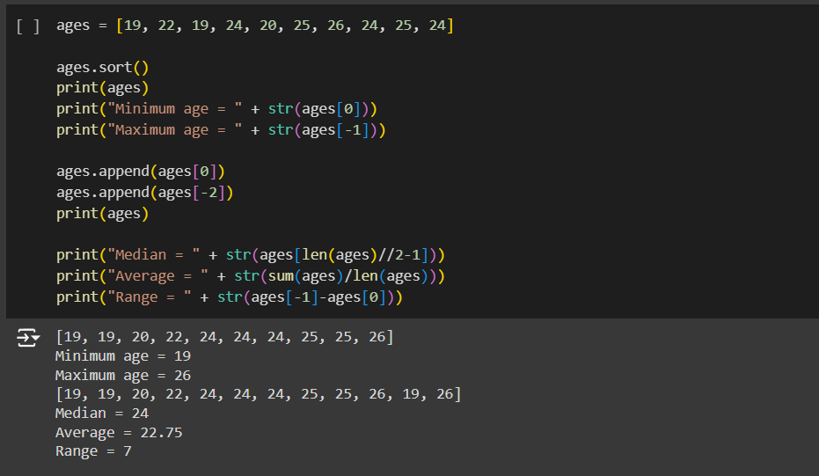

**Description:**

* Creating an empty dictionary called dog
* Adding name, color, breed, legs, age to the dog dictionary
* Creating a student dictionary and add first_name, last_name, gender, age, marital status, skills, country, city and address as keys for the dictionary
* Getting the length of the student dictionary
* Getting the value of skills and check the data type, it should be a list
* Modifying the skills values by adding one or two skills
* Getting the dictionary keys as a list
* Getting the dictionary values as a list

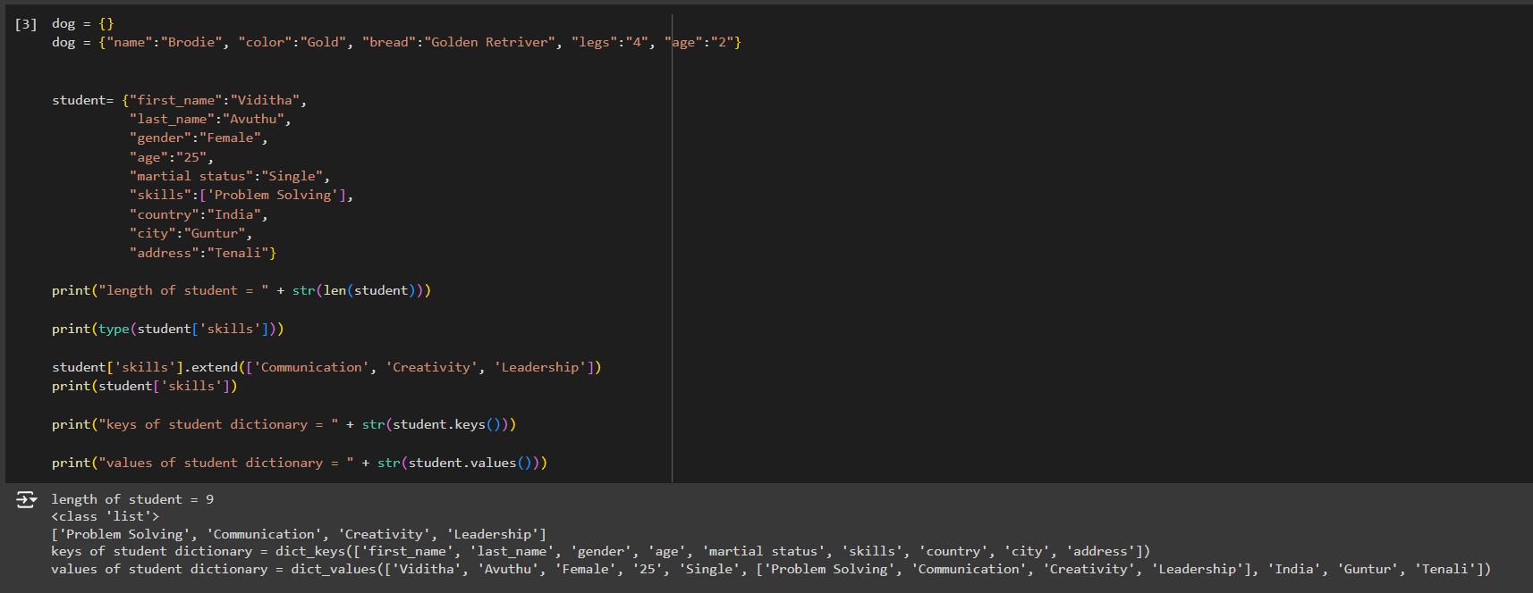

**Description:**

* Create a tuple containing names of your sisters and your brothers
* Join brothers and sisters tuples and assign it to siblings
* Finding total no of siblings
* Modify the siblings tuple and add the name of your father and mother and assign it to family_members

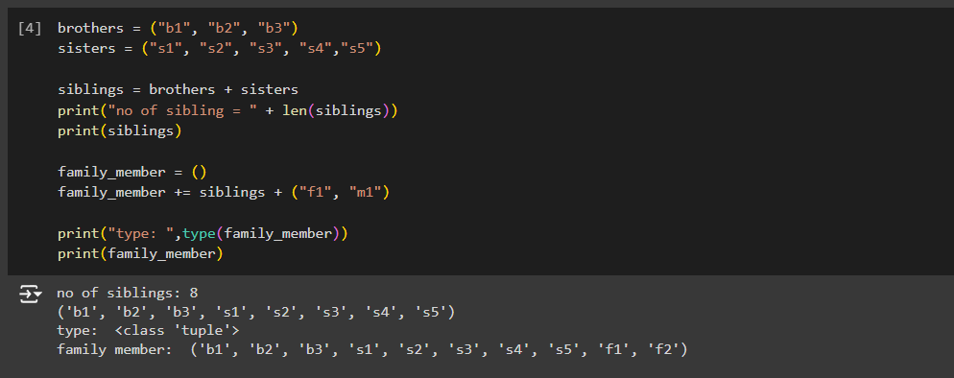

**Description:**

* Finding the length of the set it_companies
* Adding 'Twitter' to it_companies
* Inserting multiple IT companies at once to the set it_companies
* Removing one of the companies from the set it_companies
* Joining A and B
* Finding A intersection B
* Checking if A is subset of B
* Checking if A and B are disjoint sets
* Joining A with B and B with A
* Finding symmetric difference between A and B
* Deleteing the sets completely
* Converting the ages to a set and compare the length of the list and the set.

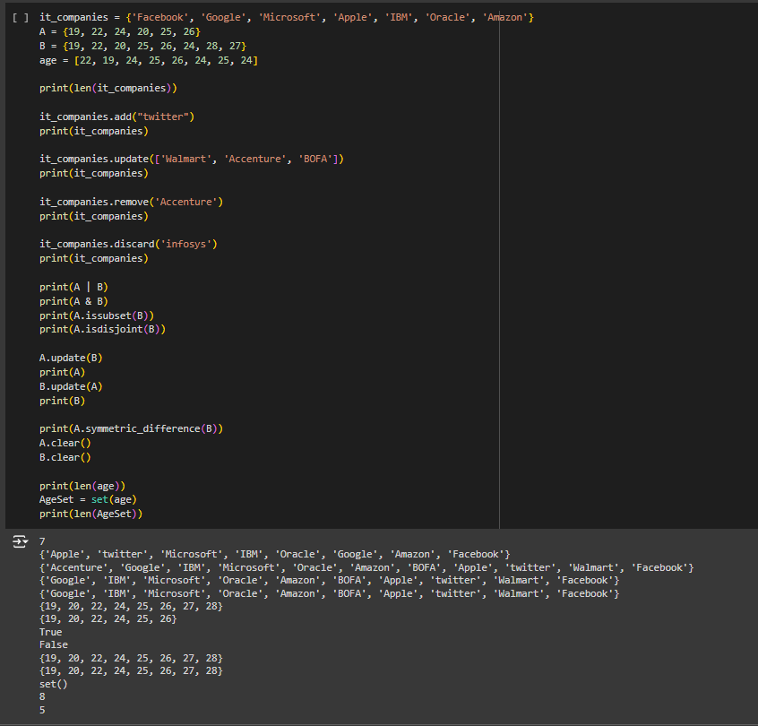

**Description:**

* Calculate the area of a circle and assign the value to a variable name of _area_of_circle_
* Calculate the circumference of a circle and assign the value to a variable name of _circum_of_circle_
* Take radius as user input and calculate the area.

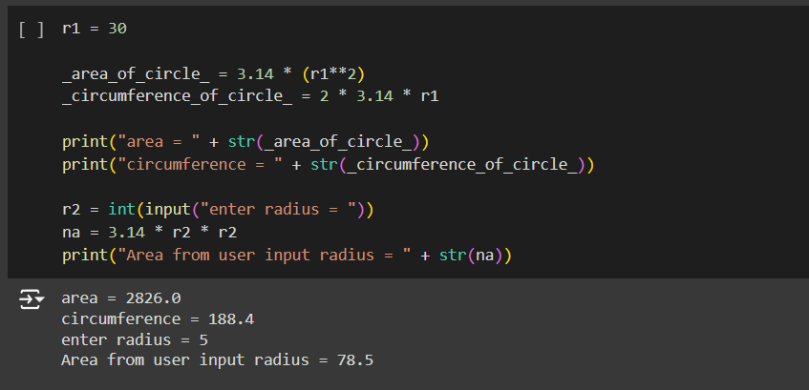

**Description:**

* Finding unique words that have been used in the sentence using the split methods and set to get the unique words.

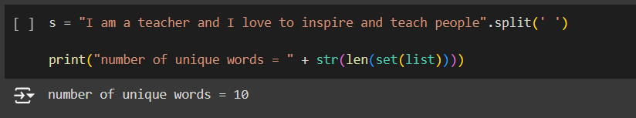

**Description:**

* Using a tab escape sequence to get the following lines.

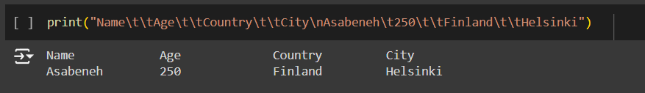

**Description:**

* Using the string formatting method to display the following output.

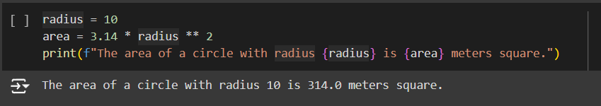

**Description:**

* Converting weights in lbs to kilograms in a separate list

